SIR APOLLO
MID TERM III EXAMINATION 2023
PRIMARY TWO
LITERACY 1B

My name is ___________________________________________

I am in ________________________________________________

My school is __________________________________________

SECTION A
1. Who treats sick children at school?
_______________________________________________________________
2. Mention one example of an activity done in our community.
_____________________________________________________________
3. Write the work of a teacher in the community
_____________________________________________________________
4. What is transport?
_______________________________________________________
- Name this craft used to keep drinking water.
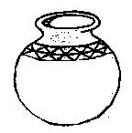

- How is a cow useful to us?
__________________________________________________________
7. Name one example of a cultural practice.
___________________________________________________________
8. Name one thing that can help a person find where our school is.___________________________________________________
9. What is the use of a broom in the classroom?
_____________________________________________________________
- Draw and name one type of weather
- What is the use of a market in our community?
_______________________________________________________________
12. Write one means of transport used on water. ____________________________________________________________
13. What is the main source of water?
_____________________________________________________________
14. State cause of road accident.
____________________________________________________________
15. Draw this example of a temporary house.
16. Give one reason why people make mats in crafts.
________________________________________________________
17. Name the animal people keep for security.
________________________________________________________
18. Write one role of a carpenter.
______________________________________________________
19. State one example of strong building material.
________________________________________________________
20. What is the work of doctor?
________________________________________________________
SECTION B
21. Name these things we make from animal skin
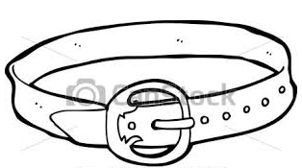 | 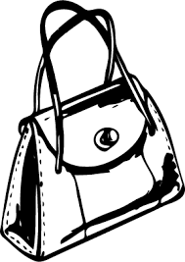
b) Write two sources of materials used to make crafts
i) _______________________________ ii) _________________________
22. Match the people to their places of work.
Cook classroom

Carpenter saloon

Teacher kitchen

Barber workshop
23. Draw these things found in our classroom.
book | ruler | chalkboard | duster

24. (a) On which part of the school uniform is a motto?
___________________________________________________
(b) How is a toilet useful in a school?
___________________________________________________
(c) Name the place in our school where children go to borrow books.
___________________________________________________
(d) Give one reason why some children in your class do not get good marks.
___________________________________________________
25.a) Give the means of communication used at school to tell pupils
about the next activity.
________________________________________________________
b) Name these means of communication.
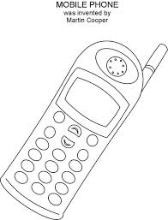 | 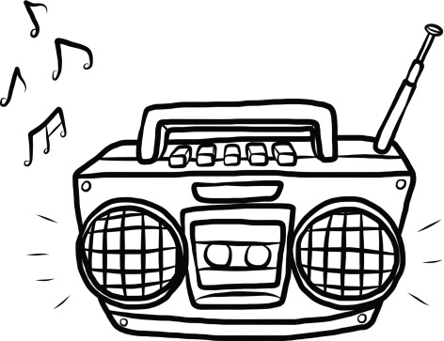 | 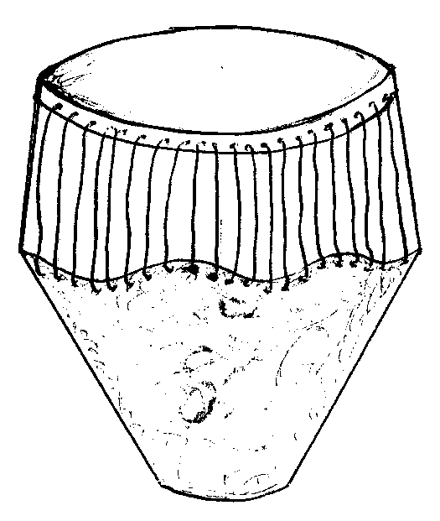
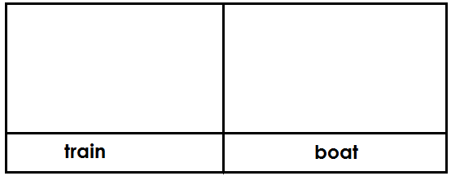26.(a) Draw the means of transport named below.

(b) Give one use of roads in a community.
___________________________________________________________
(c) Mention one problem faced by people using road transport.
____________________________________________________________
END

